

NAME: OBUONG CLAIRE ANYANGO
ADM NO : BSCCS/2024/52885
COURSE : BACHELOR OF SCIENCE IN COMPUTER SCIENCE
UNIT CODE: BIT4138
UNIT NAME: ADVANCED CRYPTOGRAPHY
LECTURER NAME : NYORO MICHAEL
ACADEMIC YEAR: YEAR 3

PROJECT TITLE: Secure File Encryption System
SELECTED TECHNOLOGIES:
Python
VS Code
Python Cryptography Library
OpenSSL
GitHub
GITHUB LINK
https://github.com/claireobuong/advanced-cryptography

Table of Contents
Week 1: Introduction To Advanced Cryptography 2
1.2 Student Reflection 3
2. Practical Task Report 3
2.1Comparison of Caesar Cipher and Vigenère Cipher 3
2.1.1. Introduction 3
2.1.2 Encryption Process 4
2.1.3. Advantages and Disadvantages 4
2.1.4. Security Comparison 5
2.1.5. Modern Relevance 5
2.1.6. Conclusion 5
2.2 Extra Practical Task 5
2.3 Summary 6
3. Week 2: Stream Ciphers and Pseudorandomness 6
3.1 Implementation of Classical Encryption Algorithms 6
3.2 Student Reflection 8
3.3 Assignment 1 8
3.4 Assignment 2 9
3.5 Advanced Practice Task 9
3.5 Task 3 10
3.6. Summary 10
4. Week 3: Period, Linear Complexity and Randomness Testing 11 12
4.1 Activity 1 12
4.2 Activity 2 13
4.3 Assignment 13
4.4 Advanced Programming Tasks 14
4.4.1 Task 1: User-defined Sequence Length 14
4.4.2 Task 2: Save Results to File 14
4.4.3 Task 3: Menu-Driven Testing System 14
4.4.4 Task 4: Graph Visualization using Matplotlib 15
4.5 Reflection 15
4.6 Summary 15
5. Week 4: Stream Cipher Cryptanalysis 16
5.1 Advanced Encryption Standard (AES) and Block Cipher Operations 16
5.2 Programming task 17
5.3 Research Task 18
5.4 Advancae Tasks 18
5.4.1. Menu-driven stream cipher analyzer 18
5.4.2 Randomness visualization tools 19
5.4.3 Mini cryptanalysis toolkit 19
5.5 Reflection 20
5.6 Summary 20
6. Week 5: Block Ciphers and Feistel Structures 20
6.1 Implementation of RSA Encryption and Key Management 20
6.2 Assignment 1 21
6.2.1 Simple Block Cipher Simulation 21
6.3 Assignment 2 22
6.4 Advanced Tasks 22
7. Creative task 25

Table of Figures
Figure 1: Confirms successful installation of Python and VS Code, providing the development environment required for implementing and testing cryptographic algorithms. 5
Figure 2: Verifies successful installation of the Python Cryptography library, enabling secure encryption and decryption operations within the project. 6
Figure 3: Confirms proper installation and configuration of OpenSSL, a widely used toolkit for generating cryptographic keys and certificates. 6
Figure 4: Demonstrates successful execution of a local encryption script, validating the functionality of symmetric encryption and decryption operations. 6
Figure 5: Illustrates initialization of the GitHub repository and version control setup, supporting secure code management and project tracking. 6
Figure 6: Caesar Cipher encryption of the plaintext "HELLO" using a shift value of 3. 9
Figure 7: Caesar Cipher decryption showing the recovery of the original plaintext from the ciphertext. 9
Figure 8: Vigenère Cipher encryption of the plaintext "NETWORK" using the keyword "KEY". 9
Figure 9: Demonstrates the implementation of the Caesar Cipher algorithm, where each character is shifted by a user-defined key to produce encrypted output. 10
Figure 10: Illustrates the Vigenère Cipher encryption process, where a keyword is used to generate multiple substitution alphabets, improving security over simple shift ciphers. 10
Figure 11: Confirms the successful encryption and decryption of plaintext, demonstrating that the original message can be accurately recovered using the correct key. 11
Figure 12: Demonstrates the user input interface, allowing dynamic entry of plaintext and encryption keys while validating numerical input for the Caesar Cipher. 11
Figure 13: Presents the testing results obtained using different plaintext messages and encryption keys, verifying the correctness and consistency of the implemented algorithms. 11
Figure 14: User input interface for the pseudorandom sequence generator, accepting an initial seed value. 12
Figure 15: Generated pseudorandom sequence showing the output values and the repetition pattern of the generator. 12
Figure 16: Menu-driven stream cipher application allowing users to select encryption or decryption operations. 13
Figure 17: XOR stream cipher encrypting a full sentence while preserving spaces through user input. 14
Figure 18: XOR decryption successfully recovers the original plaintext using the correct encryption key. 14
Figure 19: Implementation of a pseudorandom sequence generator for stream cipher security analysis. 15
Figure 20: Generated pseudorandom binary sequence used for randomness analysis. 15
Figure 21: Statistical testing results showing frequency, runs, and mean analysis of the generated binary sequence. 15
Figure 22: RC4-style stream cipher simulation demonstrating XOR-based encryption and decryption. 16
Figure 23: Encryption and randomness testing results successfully generated and stored for later analysis. 16
Figure 24: The program accepts a user-defined sequence length for generating binary pseudorandom values. 18
Figure 25: Menu-driven interface allowing users to select and perform randomness testing operations. 18
Figure 26: Generated binary sequence and statistical analysis results produced by the randomness testing program. 18
Figure 27: Randomness testing results successfully saved to a text file for future analysis and documentation. 19
Figure 28: Python implementation of an AES-based encryption script using the Cryptography library. 20
Figure 29: Automatic generation of a symmetric encryption key used for AES operations. 20
Figure 30: Encrypted output successfully stored in a file for secure data protection. 21
Figure 31: Successful decryption process demonstrating recovery of the original plaintext using the correct encryption key. 21
Figure 32: AES encryption performance measurement showing the execution time required for the encryption process. 21
Figure 33: LFSR generator implementation demonstrating repeated state detection, sequence period estimation and analysis of weaknesses associated with predictable pseudorandom sequences. 22
Figure 34: Menu-driven stream cipher analyzer 22
Figure 35: Menu-driven stream cipher analyzer allowing users to perform cryptographic operations through an interactive interface. 22
Figure 36: Graphical visualization of a pseudorandom binary sequence for randomness analysis. 23
Figure 37: Mini cryptanalysis toolkit integrating sequence generation, randomness testing, stream cipher simulation, and AES encryption functions. 23
Figure 38: Successful generation of RSA public and private key pairs for secure communication. 24
Figure 39: Encryption of plaintext using the RSA public key. 25
Figure 40: Successful decryption of ciphertext using the RSA private key. 25
Figure 41: RSA secure message transmission demonstrating protection of data during communication. 25
Figure 42: RSA encryption and decryption successfully tested and validated through execution time measurement. 25
Figure 43: Simple block cipher simulation demonstrating block division, substitution, and permutation operations. 25
Figure 44: Multiple encryption rounds applied to plaintext to demonstrate repeated block cipher processing. 26
Figure 45: Block padding implementation ensuring plaintext fits fixed-size encryption blocks. 27
Figure 46: Menu-driven encryption system allowing users to select different encryption operations. 27
Figure 47: Mini Feistel cipher demonstrating XOR operations and swapping during one encryption round. 28
Figure 48: GUI-based XOR stream cipher demonstrating secure encryption and successful decryption using a shared key. 29
Figure 49: Randomness analyzer generating binary sequences and evaluating frequency distribution. 30
Figure 50: Block cipher simulator implementing block division, substitution, and permutation operations. 30
Figure 51: Avalanche effect demonstration showing how a small plaintext change produces significant cryptographic differences 31
Figure 52: Digital fingerprint generator using SHA-256 hashing for message integrity verification. 31

Week 1: Introduction To Advanced Cryptography
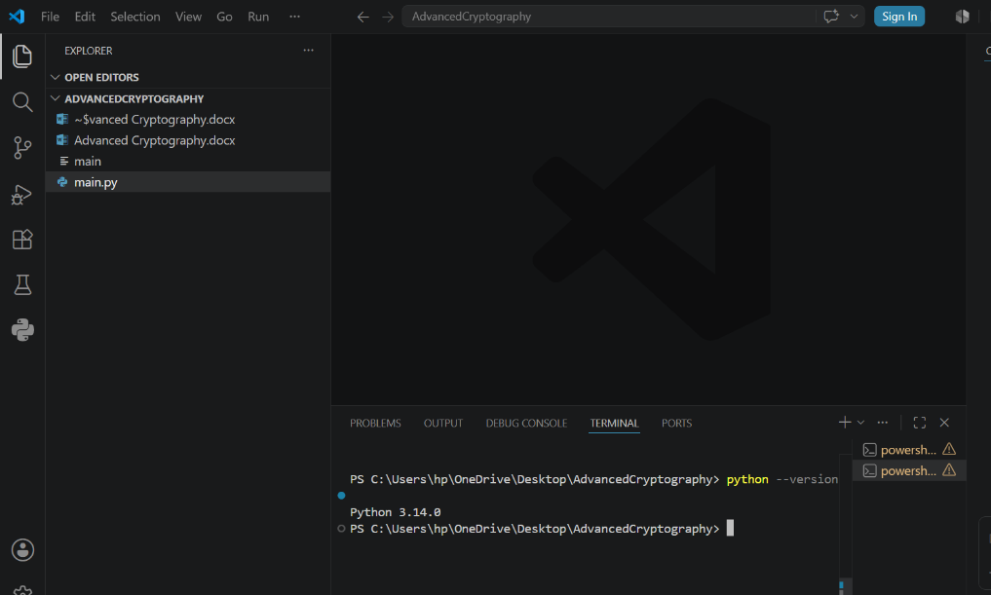
Figure 1: Confirms successful installation of Python and VS Code, providing the development environment required for implementing and testing cryptographic algorithms.

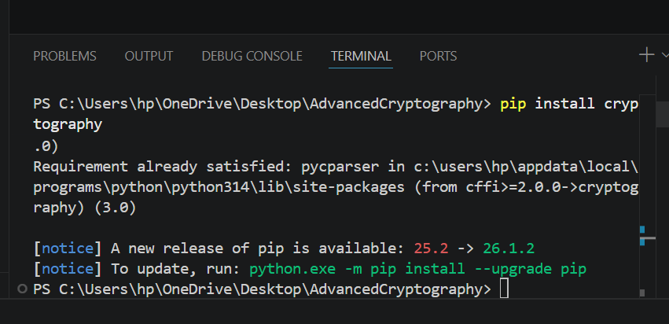
Figure 2: Verifies successful installation of the Python Cryptography library, enabling secure encryption and decryption operations within the project.

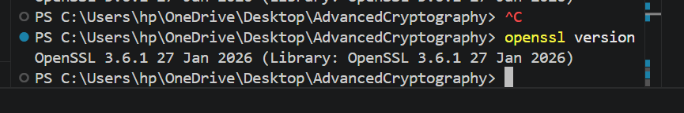
Figure 3: Confirms proper installation and configuration of OpenSSL, a widely used toolkit for generating cryptographic keys and certificates.
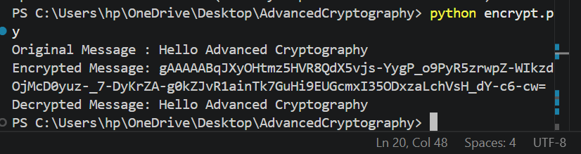
Figure 4: Demonstrates successful execution of a local encryption script, validating the functionality of symmetric encryption and decryption operations.

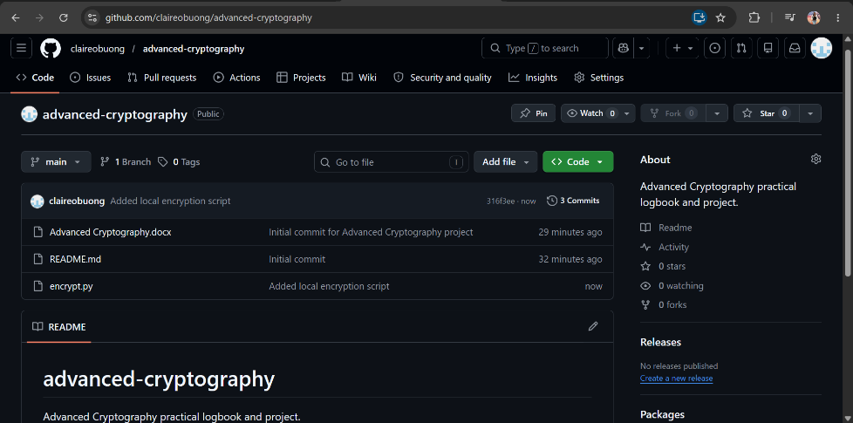
Figure 5: Illustrates initialization of the GitHub repository and version control setup, supporting secure code management and project tracking.

1.2 Student Reflection
This week's activities helped me understand the setup required for practical cryptography development. I configured essential security tools, tested encryption scripts, and learned the importance of OpenSSL and version control in secure software development.

2. Practical Task Report

2.1Comparison of Caesar Cipher and Vigenère Cipher

2.1.1. Introduction
Cryptography is the science of protecting information from unauthorized access through the use of encryption techniques. Classical cryptography introduced several methods for securing communication before the development of modern computer-based encryption systems. Among the most common classical ciphers are the Caesar Cipher and the Vigenère Cipher.

2.1.2 Encryption Process
Caesar Cipher
The Caesar Cipher is a substitution cipher where each letter in the plaintext is shifted by a fixed number of positions in the alphabet.
Example:
Plaintext: HELLO
Shift: 3
Ciphertext: KHOOR
Vigenère Cipher
The Vigenère Cipher is a polyalphabetic substitution cipher that uses a keyword to determine different shifts for each letter.
Example:
Plaintext: HELLO
Keyword: KEYKE
Ciphertext: RIJVS

2.1.3. Advantages and Disadvantages
Caesar Cipher
Advantages
- Simple and easy to implement.
- Fast encryption and decryption.
Disadvantages
- Small key space.
- Easily broken using brute force or frequency analysis.

Vigenère Cipher
Advantages
- More secure than the Caesar Cipher.
- Uses multiple alphabets, making attacks more difficult.
Disadvantages
- Weak when short or repeated keywords are used.
- Requires proper key management.

2.1.4. Security Comparison
The Caesar Cipher offers minimal security because it has only a limited number of possible keys. An attacker can quickly discover the correct shift using brute force techniques.
The Vigenère Cipher provides stronger protection by applying different shifts based on a keyword. Although it is more secure than the Caesar Cipher, it can still be broken using cryptanalysis methods if the keyword is predictable.

2.1.5. Modern Relevance
Although classical ciphers are no longer suitable for protecting sensitive information, they remain important for learning the fundamental principles behind modern cryptographic systems. Concepts such as substitution, key management, and encryption algorithms form the basis of advanced encryption standards used today.

2.1.6. Conclusion
The Caesar Cipher and Vigenère Cipher represent important milestones in the history of cryptography. While the Caesar Cipher is simple but weak, the Vigenère Cipher offers improved security through multiple substitution alphabets. Studying these classical methods helps build a strong foundation for understanding modern cryptographic techniques.

2.2 Extra Practical Task
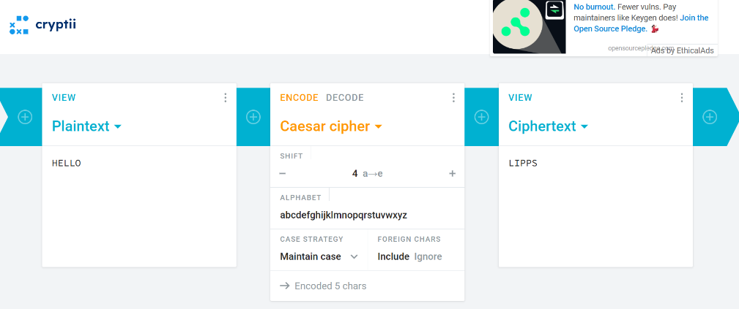
Figure 6: Caesar Cipher encryption of the plaintext "HELLO" using a shift value of 3.
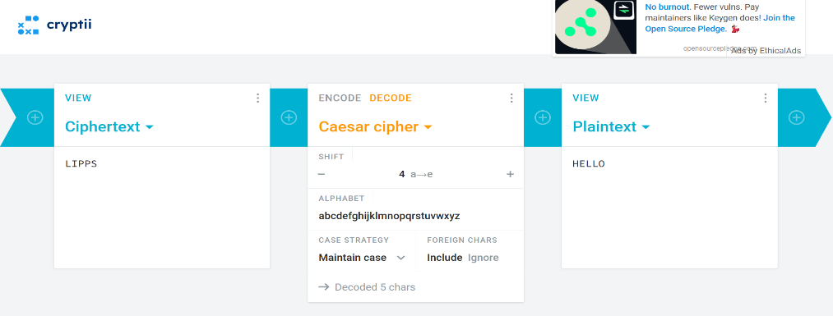
Figure 7: Caesar Cipher decryption showing the recovery of the original plaintext from the ciphertext.
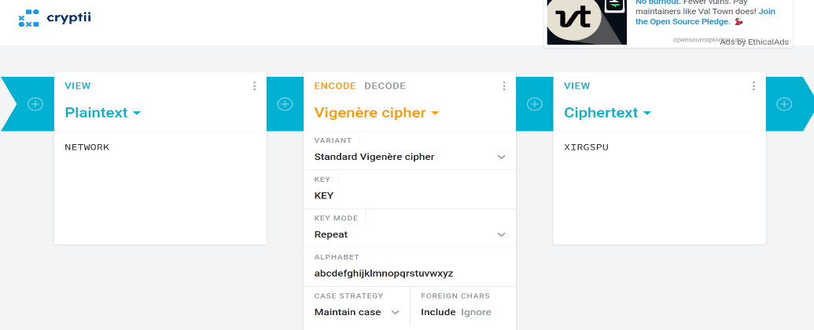
Figure 8: Vigenère Cipher encryption of the plaintext "NETWORK" using the keyword "KEY".

2.3 Summary
Week 1 focused on establishing a secure cryptographic development environment through software installation, encryption testing, and version control setup. These activities provided a practical foundation for implementing and analyzing cryptographic algorithms in future exercises.

3. Week 2: Stream Ciphers and Pseudorandomness

3.1 Implementation of Classical Encryption Algorithms
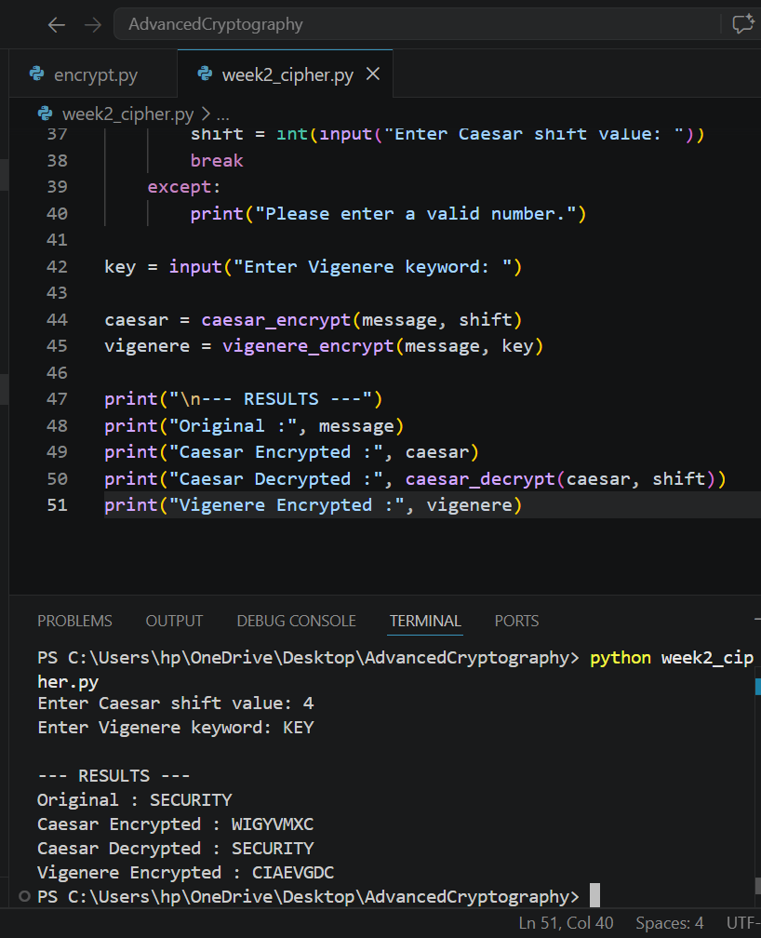
Figure 9: Demonstrates the implementation of the Caesar Cipher algorithm, where each character is shifted by a user-defined key to produce encrypted output.
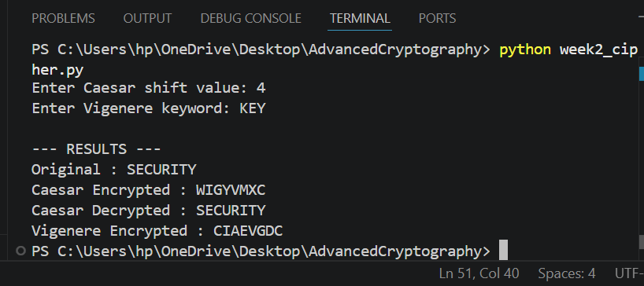
Figure 10: Illustrates the Vigenère Cipher encryption process, where a keyword is used to generate multiple substitution alphabets, improving security over simple shift ciphers.

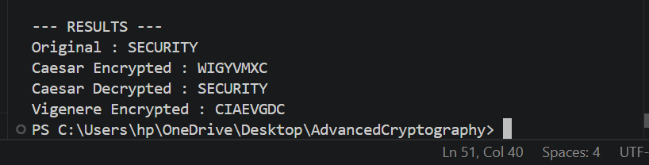
Figure 11: Confirms the successful encryption and decryption of plaintext, demonstrating that the original message can be accurately recovered using the correct key.

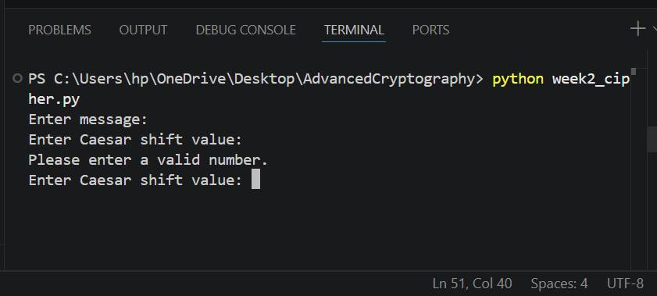
Figure 12: Demonstrates the user input interface, allowing dynamic entry of plaintext and encryption keys while validating numerical input for the Caesar Cipher.

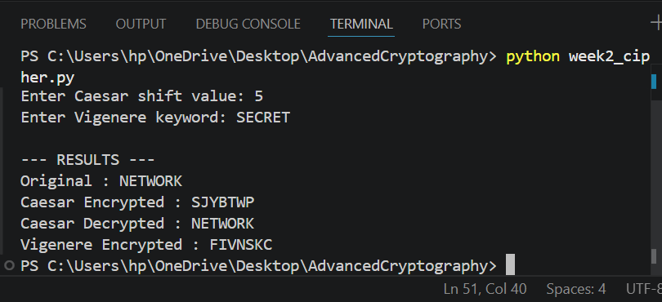
Figure 13: Presents the testing results obtained using different plaintext messages and encryption keys, verifying the correctness and consistency of the implemented algorithms.

3.2 Student Reflection
This week's activities demonstrated how classical encryption algorithms transform plaintext into ciphertext using secret keys. Implementing Caesar and Vigenère ciphers improved my understanding of encryption workflows, key management and the security weaknesses of simple substitution techniques.

3.3 Assignment 1
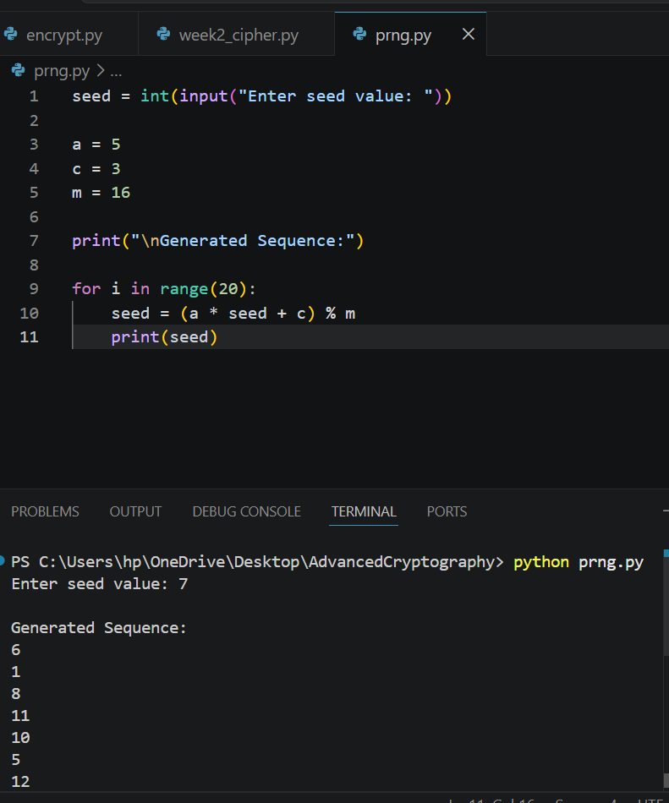
Figure 14: User input interface for the pseudorandom sequence generator, accepting an initial seed value.

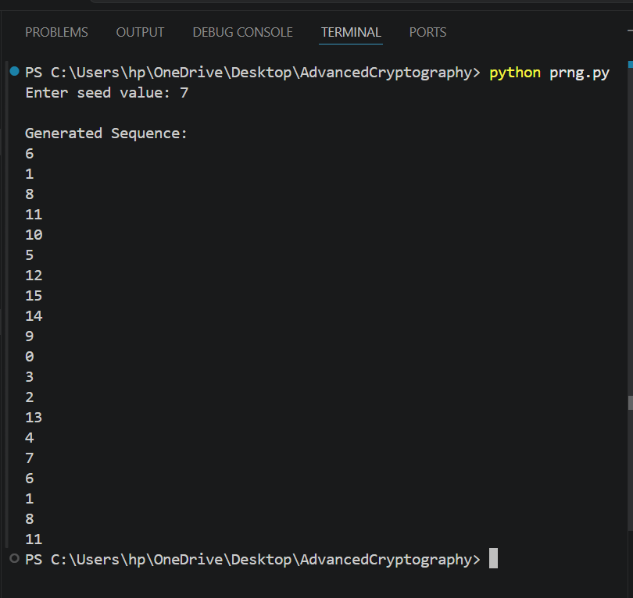
Figure 15: Generated pseudorandom sequence showing the output values and the repetition pattern of the generator.

3.4 Assignment 2
One-Time Pad (OTP)
- Key length equals message length.
- Key is truly random.
- Key is used only once.
- Considered theoretically unbreakable.
RC4 Stream Cipher
- Stream cipher using a pseudorandom keystream.
- Fast and simple.
- Previously used in SSL/TLS and WEP.
- No longer recommended due to security vulnerabilities.
Real-world Applications
- Secure messaging systems.
- VPNs.
- Wireless communication.
- Data encryption systems.
- Military and government communications.

3.5 Advanced Practice Task
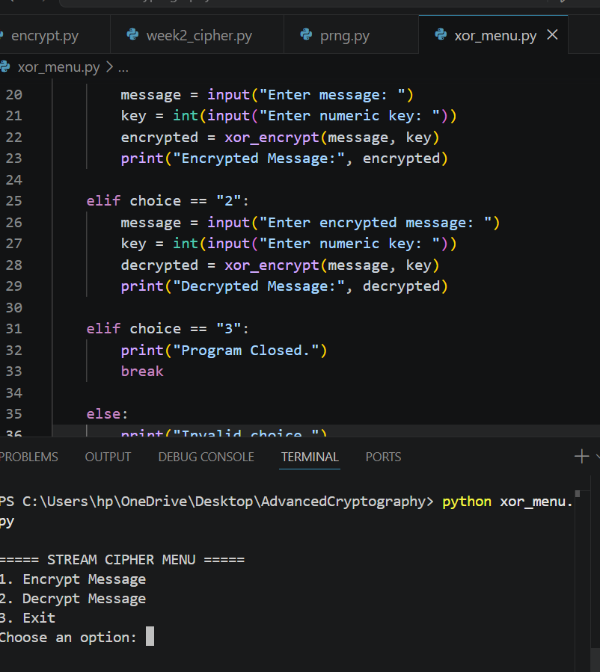
Figure 16: Menu-driven stream cipher application allowing users to select encryption or decryption operations.

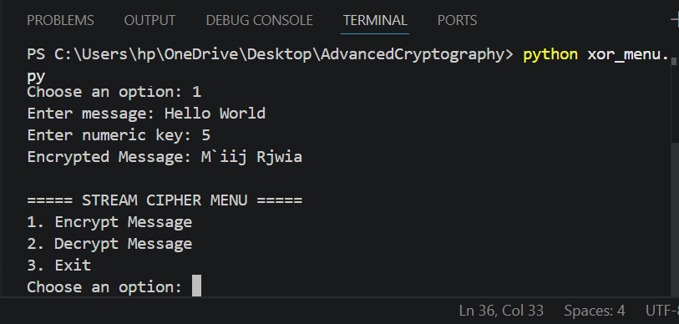
Figure 17: XOR stream cipher encrypting a full sentence while preserving spaces through user input.

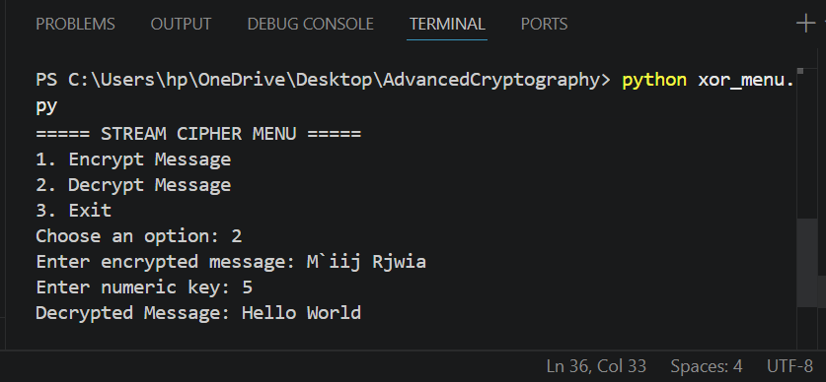
Figure 18: XOR decryption successfully recovers the original plaintext using the correct encryption key.

3.5 Task 3
Feature | True Random Generator | Pseudorandom Generator
Security | Very high because values come from physical processes. | High, but depends on the algorithm used.
Cost | Expensive due to specialized hardware. | Low because it is software-based.
Speed | Generally slower. | Faster and efficient.
Practicality | Used in highly secure environments. | Commonly used in everyday computing and cryptography.

3.6. Summary
Week 2 focused on implementing classical encryption algorithms and evaluating their effectiveness. Practical exercises highlighted the importance of keys, encryption processes, and the limitations of traditional ciphers against modern cryptanalysis methods.

4. Week 3: Period, Linear Complexity and Randomness Testing

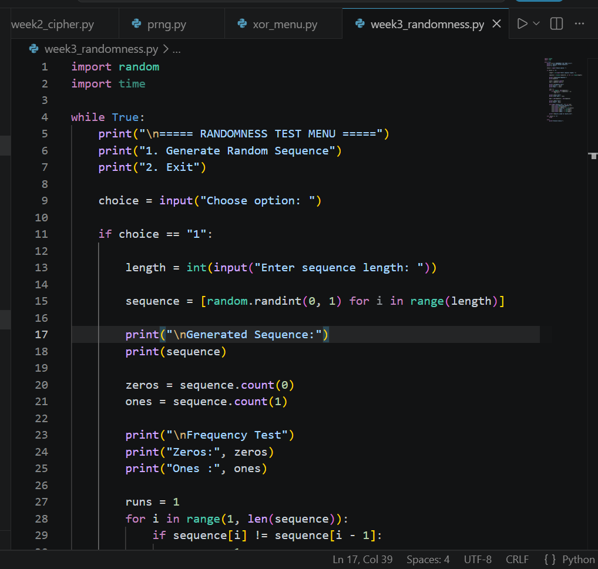
Figure 19: Implementation of a pseudorandom sequence generator for stream cipher security analysis.

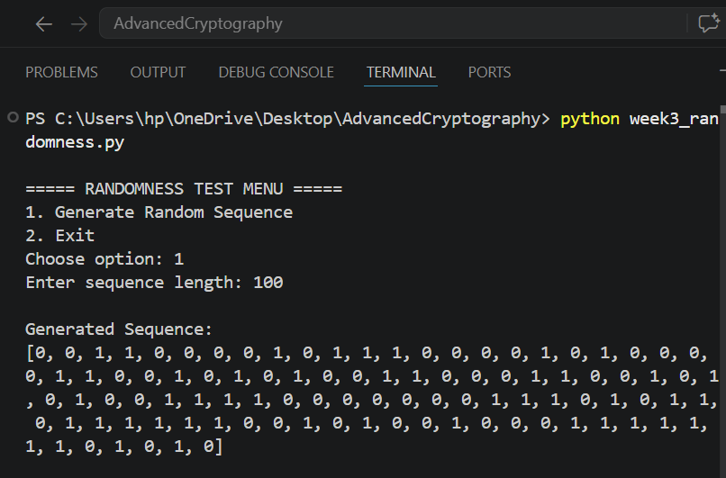
Figure 20: Generated pseudorandom binary sequence used for randomness analysis.

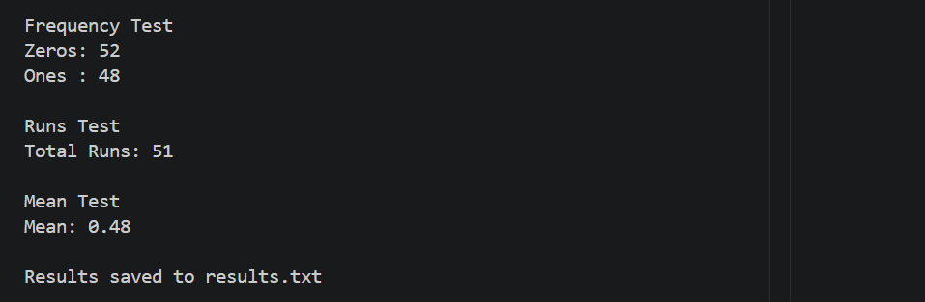
Figure 21: Statistical testing results showing frequency, runs, and mean analysis of the generated binary sequence.

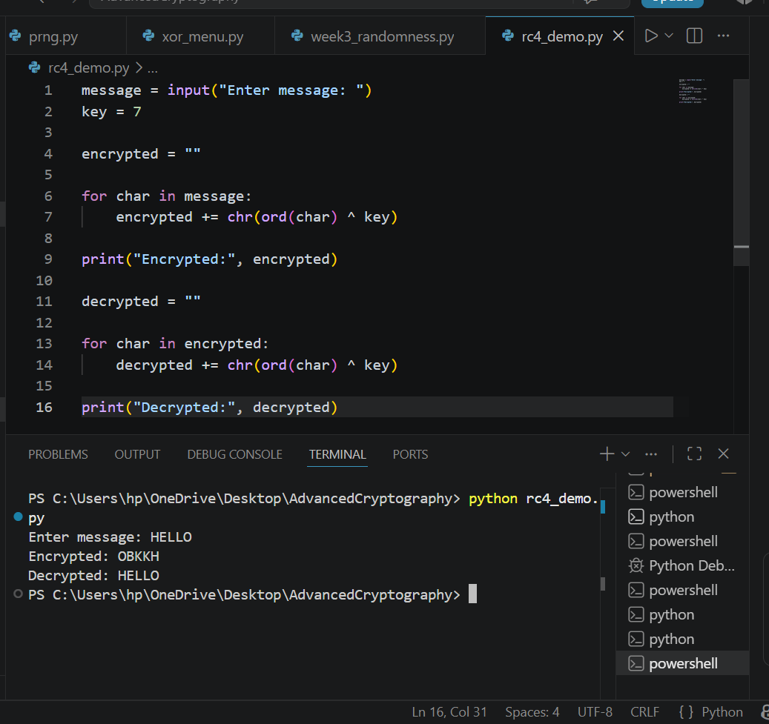
Figure 22: RC4-style stream cipher simulation demonstrating XOR-based encryption and decryption.

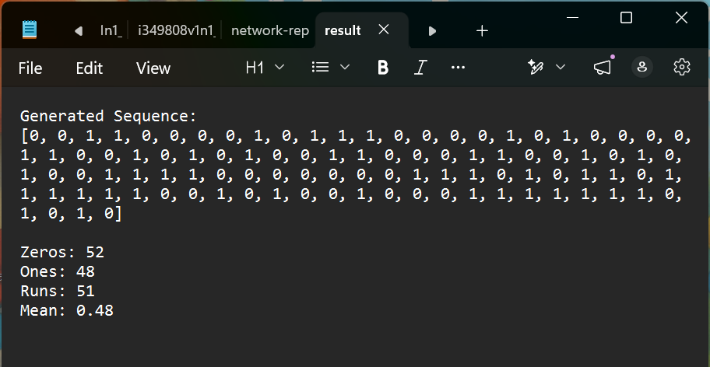
Figure 23: Encryption and randomness testing results successfully generated and stored for later analysis.

4.1 Activity 1
Sequence | Period
2,5,7,2,5,7 | 3
Observation
Changing the modulus affects how quickly the sequence repeats.

4.2 Activity 2
Property | Observation
Frequency Balance | Nearly equal zeros and ones
Runs Count | Moderate alternation
Repetition | Minimal over short sequences

4.3 Assignment
Importance of Randomness
Randomness ensures that cryptographic keys and keystreams are unpredictable, making encrypted data difficult for attackers to reproduce or guess.
Weak Random Generators
Weak generators produce predictable outputs that can allow attackers to recover secret keys and compromise encryption systems.
Historical Cryptographic Failures
Debian OpenSSL Bug
A programming error introduced in 2006 significantly reduced the randomness used for key generation, making cryptographic keys predictable.
Weak Encryption Keys
Poor random number generation has caused many security breaches where attackers could guess or recreate encryption keys.

4.4 Advanced Programming Tasks

4.4.1 Task 1: User-defined Sequence Length

Figure 24: The program accepts a user-defined sequence length for generating binary pseudorandom values.

4.4.2 Task 2: Save Results to File

Figure 25: Menu-driven interface allowing users to select and perform randomness testing operations.

4.4.3 Task 3: Menu-Driven Testing System
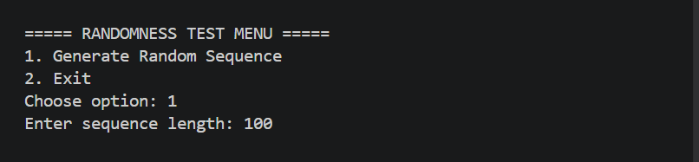
Figure 26: Generated binary sequence and statistical analysis results produced by the randomness testing program.

4.4.4 Task 4: Graph Visualization using Matplotlib
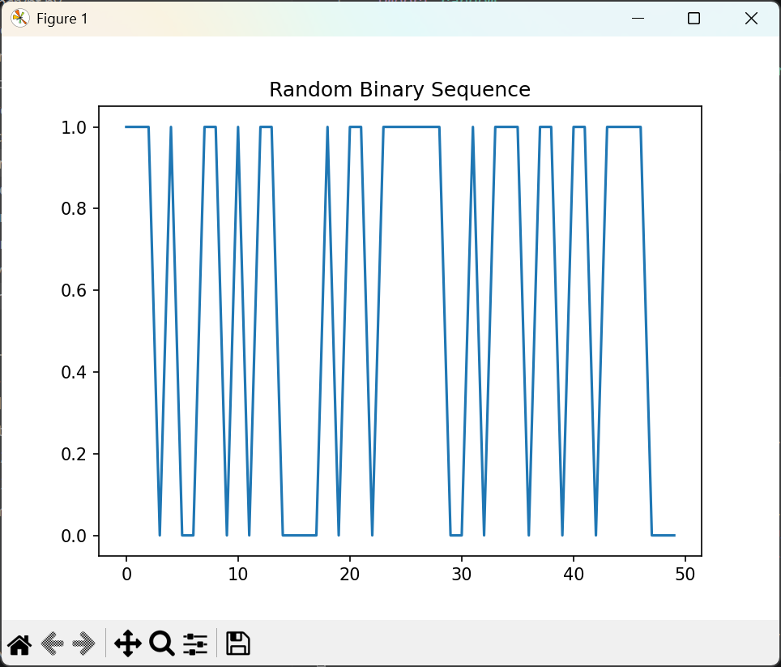
Figure 27: Randomness testing results successfully saved to a text file for future analysis and documentation.

4.5 Reflection
This week's activities demonstrated the importance of randomness in stream cipher security. Implementing pseudorandom sequence generation and statistical testing improved my understanding of how randomness affects encryption strength and how weak generators can introduce cryptographic vulnerabilities.

4.6 Summary
Week 3 focused on stream cipher security through pseudorandom sequence generation and randomness testing. Practical exercises involving statistical analysis and simple stream cipher simulations provided insight into the role of unpredictability in modern cryptographic systems.

5. Week 4: Stream Cipher Cryptanalysis

5.1 Advanced Encryption Standard (AES) and Block Cipher Operations
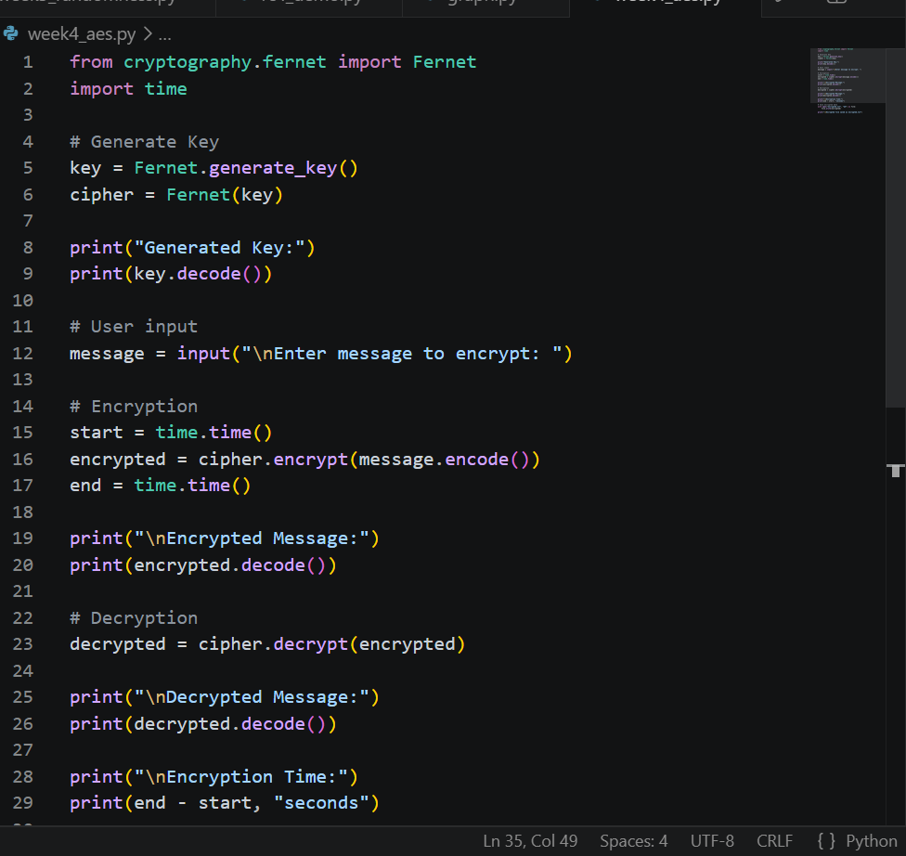
Figure 28: Python implementation of an AES-based encryption script using the Cryptography library.

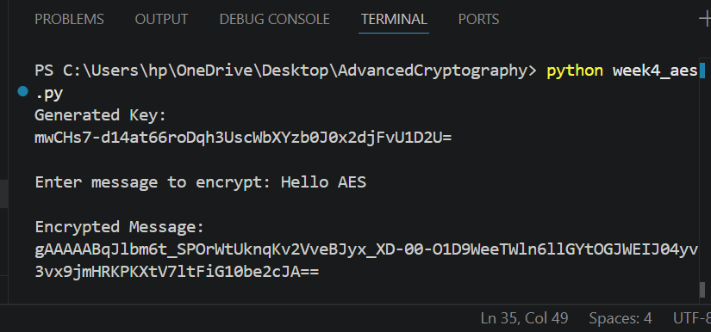
Figure 29: Automatic generation of a symmetric encryption key used for AES operations.

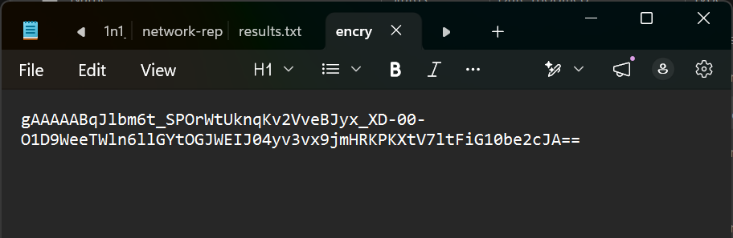
Figure 30: Encrypted output successfully stored in a file for secure data protection.

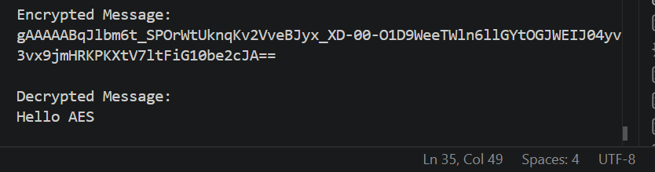
Figure 31: Successful decryption process demonstrating recovery of the original plaintext using the correct encryption key.

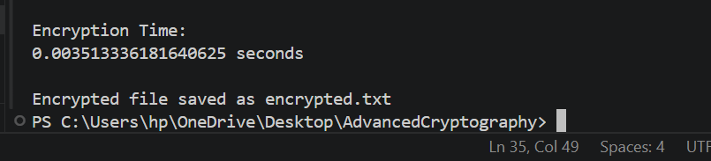
Figure 32: AES encryption performance measurement showing the execution time required for the encryption process.

5.2 Programming task
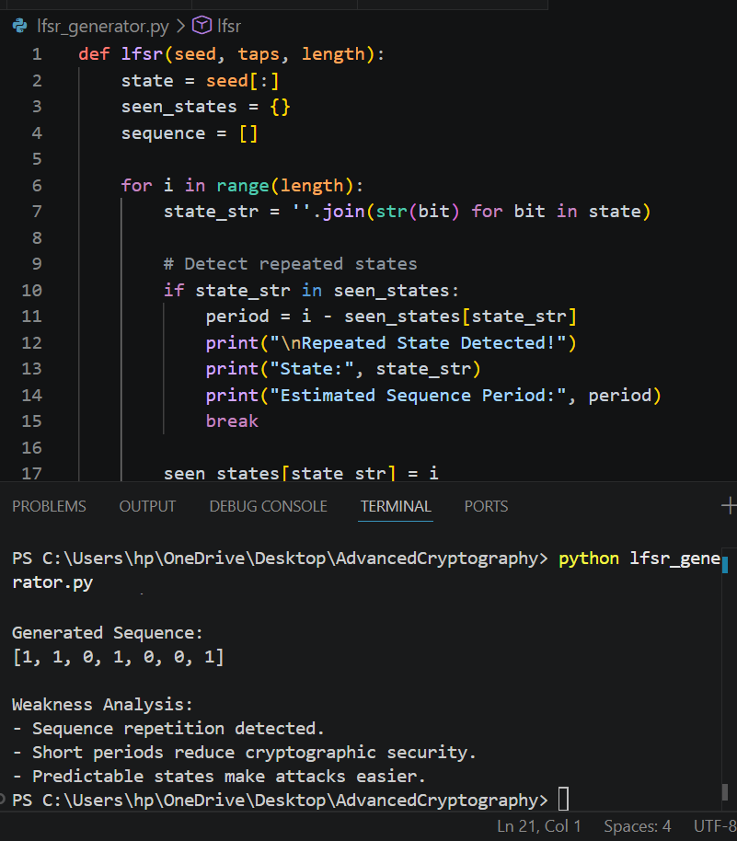
Figure 33: LFSR generator implementation demonstrating repeated state detection, sequence period estimation and analysis of weaknesses associated with predictable pseudorandom sequences.

5.3 Research Task
Berlekamp-Massey Algorithm
The Berlekamp-Massey Algorithm determines the shortest Linear Feedback Shift Register (LFSR) capable of generating a binary sequence. It is commonly used to measure linear complexity and evaluate the security of stream ciphers.
Algebraic Attacks
Algebraic attacks transform encryption operations into mathematical equations and solve them to recover secret information. Weak nonlinear components increase vulnerability to these attacks.
RC4 Vulnerabilities
RC4 has several known weaknesses, including biased keystream generation and predictable output patterns. Due to these vulnerabilities, it has been deprecated in modern security protocols.

5.4 Advancae Tasks

5.4.1. Menu-driven stream cipher analyzer

Figure 34: Menu-driven stream cipher analyzer
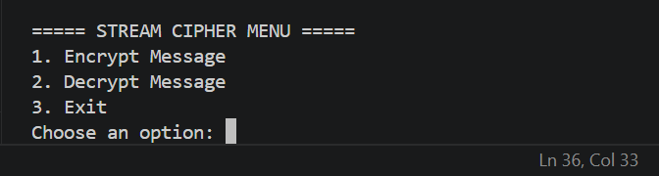
Figure 35: Menu-driven stream cipher analyzer allowing users to perform cryptographic operations through an interactive interface.

5.4.2 Randomness visualization tools
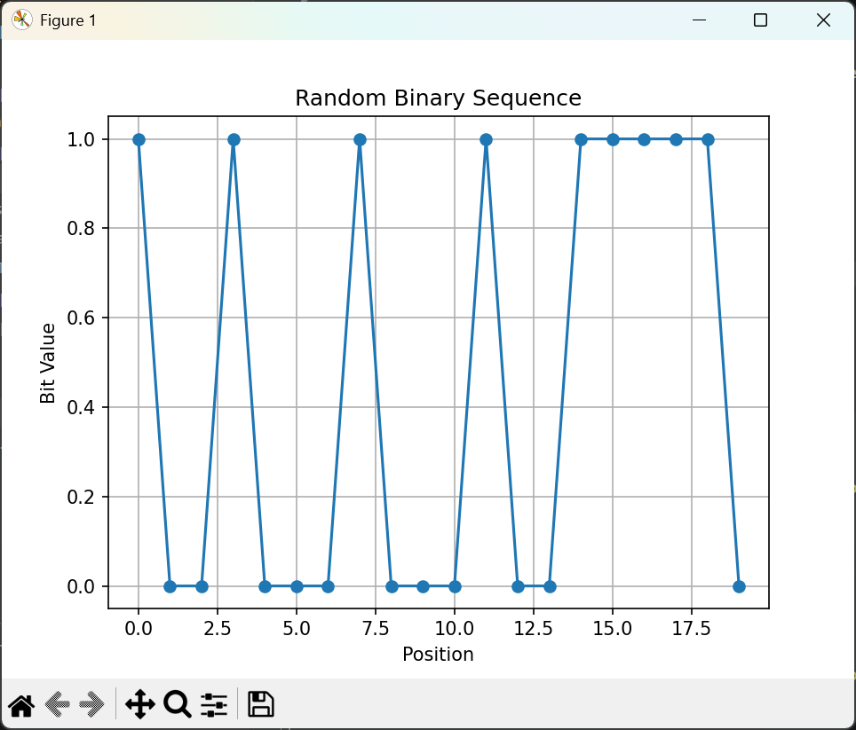
Figure 36: Graphical visualization of a pseudorandom binary sequence for randomness analysis.

5.4.3 Mini cryptanalysis toolkit
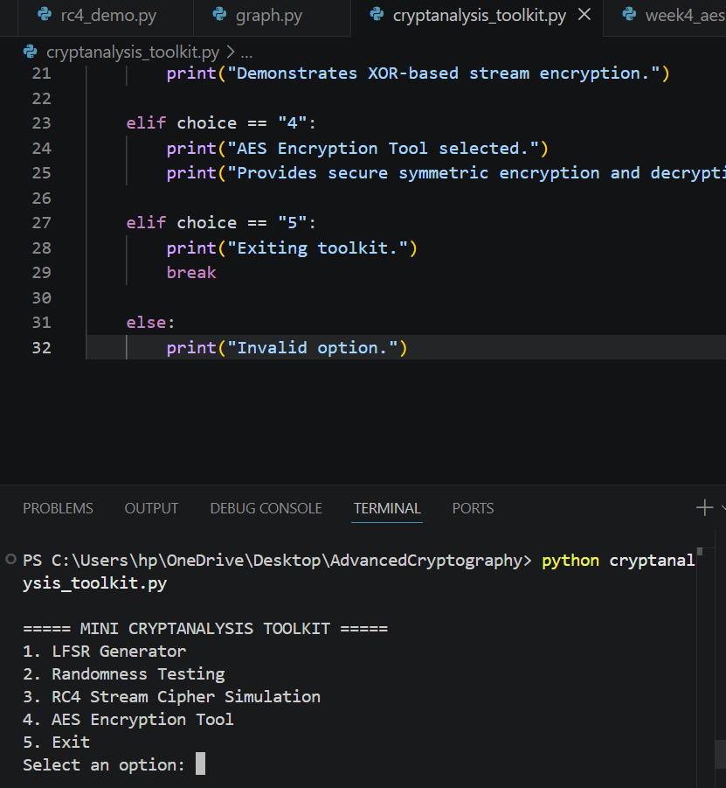
Figure 37: Mini cryptanalysis toolkit integrating sequence generation, randomness testing, stream cipher simulation, and AES encryption functions.

5.5 Reflection
This week introduced AES encryption and secure key management. Implementing encryption and decryption operations improved my understanding of symmetric cryptography, secure file protection, and the importance of safeguarding encryption keys during communication.

5.6 Summary
Week 4 focused on implementing AES encryption and studying cryptanalysis concepts. Practical exercises demonstrated secure key generation, encryption, decryption, and performance evaluation while reinforcing the importance of strong cryptographic algorithms.

6. Week 5: Block Ciphers and Feistel Structures

6.1 Implementation of RSA Encryption and Key Management
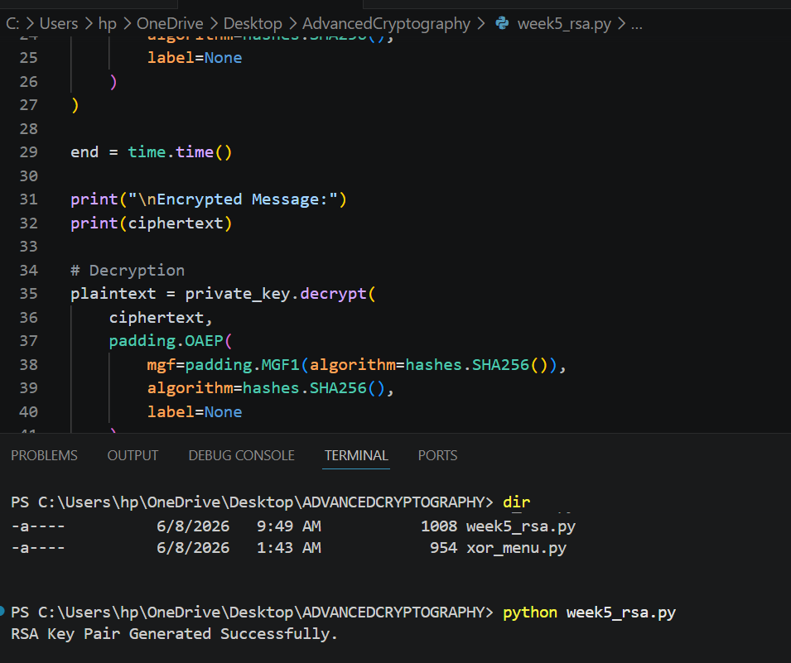
Figure 38: Successful generation of RSA public and private key pairs for secure communication.

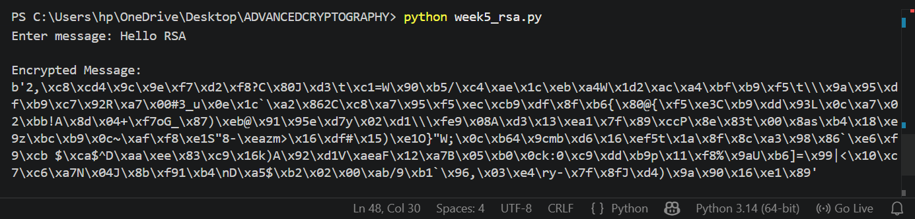
Figure 39: Encryption of plaintext using the RSA public key.
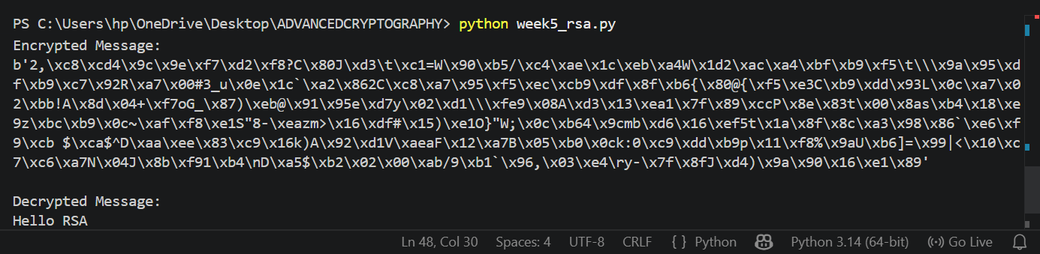
Figure 40: Successful decryption of ciphertext using the RSA private key.


Figure 41: RSA secure message transmission demonstrating protection of data during communication.

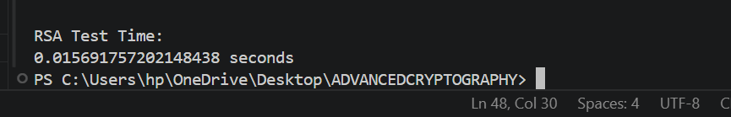
Figure 42: RSA encryption and decryption successfully tested and validated through execution time measurement.

6.2 Assignment 1

6.2.1 Simple Block Cipher Simulation
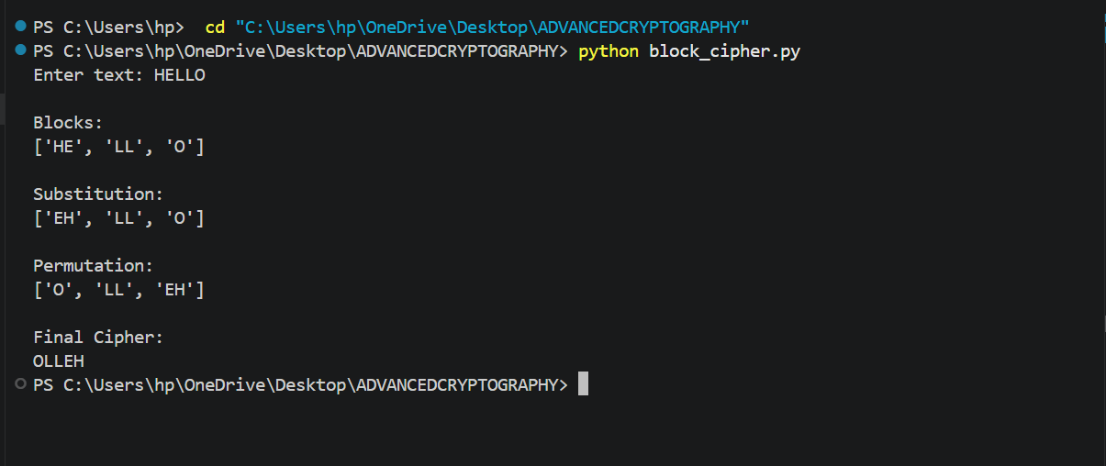
Figure 43: Simple block cipher simulation demonstrating block division, substitution, and permutation operations.

6.3 Assignment 2
DES
DES is a symmetric block cipher that encrypts 64-bit blocks using a 56-bit key through a Feistel structure.
AES
AES is a modern symmetric block cipher that provides stronger security using substitution and permutation operations.
Feistel Structure
A Feistel network divides plaintext into left and right halves and applies multiple rounds of XOR and swapping operations.
Confusion and Diffusion
Confusion hides the relationship between the key and ciphertext, while diffusion spreads plaintext changes throughout the ciphertext.

6.4 Advanced Tasks

6.4.1 Task 1: Add Multiple Rounds
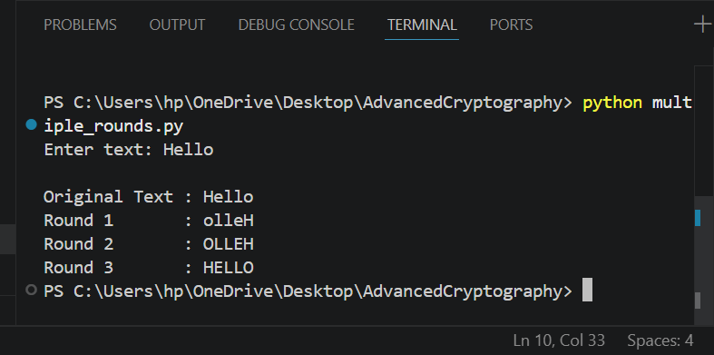
Figure 44: Multiple encryption rounds applied to plaintext to demonstrate repeated block cipher processing.

6.4.2 Task 2: Implement Block Padding
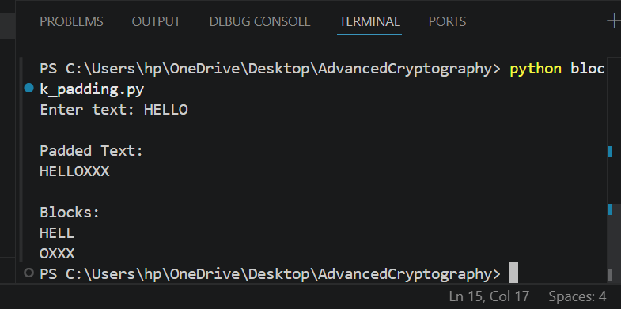
Figure 45: Block padding implementation ensuring plaintext fits fixed-size encryption blocks.

6.4.3 Task 3: Build Menu-Driven Encryption System
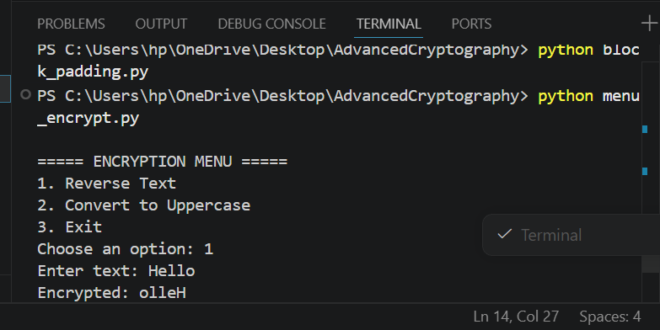
Figure 46: Menu-driven encryption system allowing users to select different encryption operations.

6.4.4 Task 4: Develop Mini Feistel Cipher
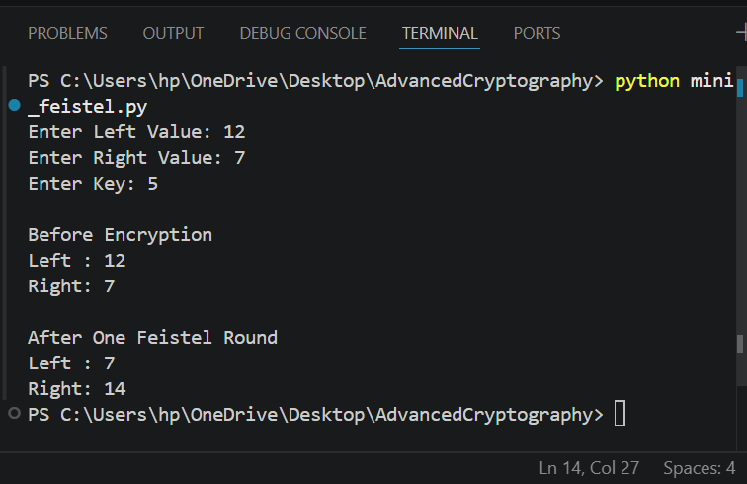
Figure 47: Mini Feistel cipher demonstrating XOR operations and swapping during one encryption round.

6.5 Summary
RSA encryption and block cipher concepts were implemented through practical simulations and a GUI cryptography toolkit. The project demonstrated key generation, secure communication, avalanche effect analysis, and SHA-256 hashing, reinforcing both asymmetric encryption and modern security principles.

7. Creative task
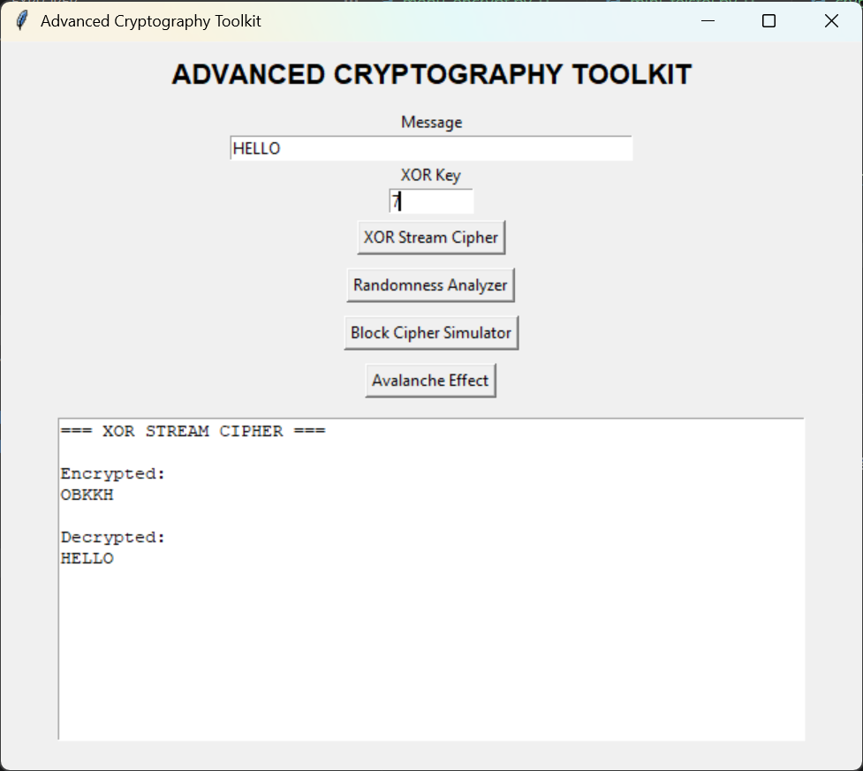
Figure 48: GUI-based XOR stream cipher demonstrating secure encryption and successful decryption using a shared key.

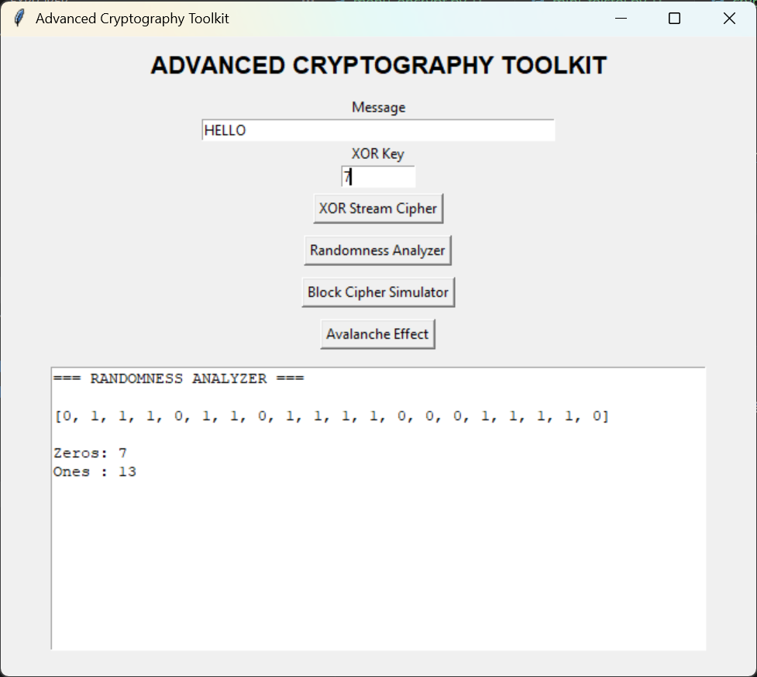
Figure 49: Randomness analyzer generating binary sequences and evaluating frequency distribution.
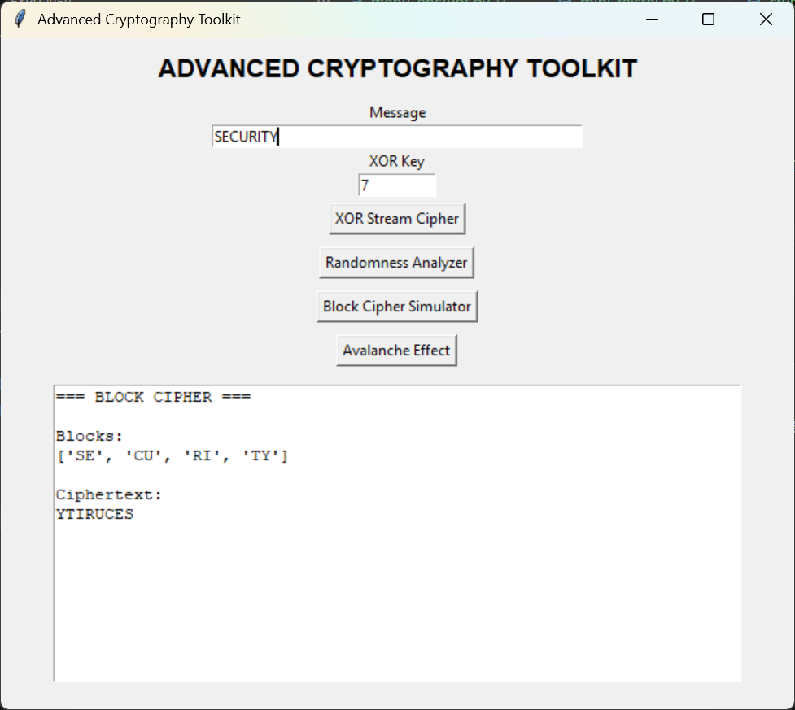
Figure 50: Block cipher simulator implementing block division, substitution, and permutation operations.
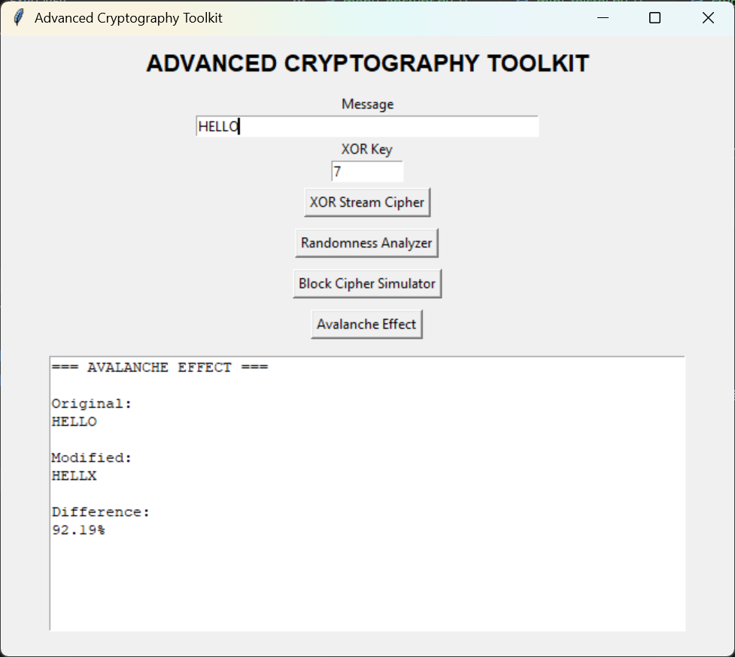
Figure 51: Avalanche effect demonstration showing how a small plaintext change produces significant cryptographic differences
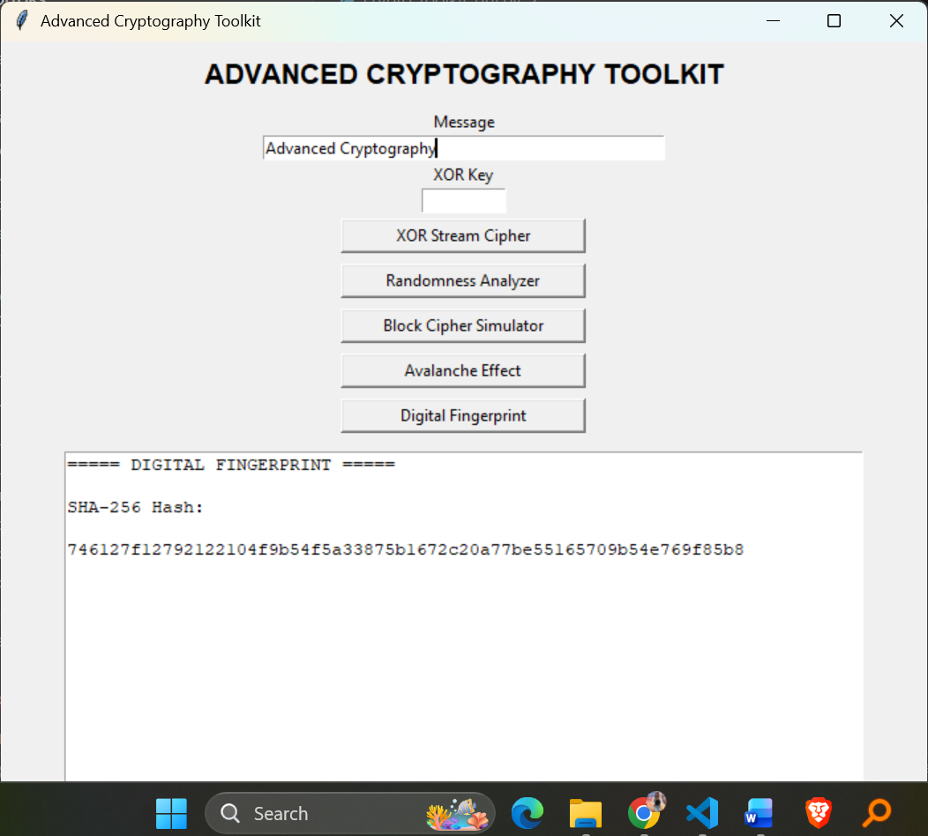
Figure 52: Digital fingerprint generator using SHA-256 hashing for message integrity verification.

